Table of Contents

S. No | Title | Page No
1 | ABSTRACT | 4
2 | INTRODUCTION | 5
3 | OBJECTIVES | 7
4 | PROBLEM STATEMENT | 10
5 | SCOPE OF THE PROJECT | 11
6 | LITERATURE SURVEY | 13
7 | METHODOLOGY | 16
8 | SYSTEM ARCHITECTURE | 21
9 | TOOLS & TECHNOLOGIES | 23
10 | IMPLEMENTATION | 25
11 | RESULTS & OUTPUT | 31
12 | APPLICATIONS | 35
13 | FUTURE ENHANCEMENTS | 38
14 | CONCLUSION | 46
15 | REFERENCES | 48

- ABSTRACT

The rapid expansion of internet penetration has fundamentally transformed digital communication, simultaneously exposing local and wide-area networks to sophisticated vulnerabilities. The smallest unit of network communication, the data packet, traverses shared media and is inherently susceptible to interception if appropriate security protocols are absent. This project details the design, development, and deployment of a Real-Time Network Packet Sniffer utilizing the Python programming language and the Scapy packet manipulation framework. Unlike traditional, heavy GUI-based analyzers, this project implements a highly efficient, lightweight command-line utility capable of capturing and analyzing live network traffic at the Data Link, Network, and Transport layers.

The primary objective of this system is to place the Network Interface Card (NIC) into promiscuous mode, allowing it to passively intercept all incoming and outgoing datagrams across the network segment. The programmatic implementation meticulously dissects the captured frames, applying logical rulesets to classify the traffic based on specific protocols, including the Transmission Control Protocol (TCP), User Datagram Protocol (UDP), and Internet Control Message Protocol (ICMP). Furthermore, the system evaluates source and destination Internet Protocol (IP) addresses against the local host to accurately categorize the directional flow of traffic (Incoming vs. Outgoing). The system extracts critical metadata—such as MAC addresses, port numbers, payload sizes, and geographic IP locations—and generates real-time, timestamped console alerts and persistent log files. By bridging foundational networking concepts with practical Python scripting, this project delivers a robust tool for network troubleshooting, bandwidth monitoring, and the proactive detection of unauthorized data transmission.

- INTRODUCTION

Background of Network Security and Packet Transmission
In modern computer networks, data communication does not occur as a continuous stream of information. Instead, it is systematically segmented into smaller units known as packets, datagrams, or frames, depending on the abstraction level defined by the Open Systems Interconnection (OSI) model. At the sender’s end, large data is divided into these packets, each containing both payload and control information such as source and destination addresses, sequence numbers, and protocol-specific headers. These packets are then transmitted independently across the network through multiple intermediate devices such as switches, routers, and gateways, following potentially different paths. Upon reaching the destination, they are reassembled in the correct order to reconstruct the original message.
Historically, early Ethernet-based networks operated on a shared communication medium, where data was broadcast to all devices within the same network segment. Although modern switched networks have reduced unnecessary broadcasting, the fundamental principle of packet transmission still allows packets to be observed under certain configurations. Each device in a network is identified by a unique Media Access Control (MAC) address, and Network Interface Cards (NICs) are designed to filter and process only those packets addressed to them. However, when a NIC is placed into promiscuous mode, it bypasses this filtering mechanism, enabling the system to capture and process every packet on the network segment regardless of its intended destination. This capability forms the technical foundation of packet sniffing.

Packet Sniffing Mechanics
Packet sniffing refers to the process of intercepting, capturing, and analyzing data packets as they traverse a network. It can be conceptually compared to wiretapping in traditional telecommunication systems, where communication channels are monitored without necessarily interrupting the flow of data. Packet sniffers operate primarily at the Data Link Layer (Layer 2) and Network Layer (Layer 3) of the OSI model, although advanced tools can extend analysis up to the Application Layer (Layer 7).
When a packet is captured, it contains multiple encapsulated headers corresponding to different layers of the network stack. A packet sniffer decodes these headers to extract meaningful information such as source and destination IP addresses, protocol types (TCP, UDP, ICMP), port numbers, and payload data. This layered decoding process is known as protocol dissection. In cases where data is transmitted in plaintext, such as with legacy protocols like HTTP, FTP, or Telnet, the payload itself can be directly inspected, exposing sensitive information. However, with the increasing adoption of encryption protocols like HTTPS and TLS, payload visibility is significantly reduced, limiting sniffers primarily to metadata analysis.

Types of Cyber Attacks Utilizing Packet Sniffers
Although packet sniffing is an essential tool for legitimate network management, it is frequently exploited by malicious actors for conducting sophisticated cyber attacks. These attacks leverage the ability to observe and manipulate network traffic:

Passive Eavesdropping
In passive sniffing attacks, adversaries silently monitor network traffic without altering it. The objective is to capture sensitive data such as login credentials, financial information, and confidential communications. Since no active interference occurs, such attacks are difficult to detect. Protocols that lack encryption are particularly vulnerable to this form of exploitation.

ARP Spoofing and Man-in-the-Middle (MITM) Attacks
Address Resolution Protocol (ARP) spoofing is a technique used to manipulate the mapping between IP addresses and MAC addresses within a local network. By sending forged ARP responses, an attacker can associate their own MAC address with the IP address of a legitimate device, such as the network gateway. This allows the attacker to intercept, modify, or redirect traffic between communicating parties. In a Man-in-the-Middle (MITM) attack, the attacker effectively positions themselves between the sender and receiver, gaining full visibility and potential control over the communication channel.

Network Reconnaissance and Probing
Before launching targeted attacks, adversaries often perform reconnaissance to gather intelligence about the network. Packet sniffers are used in conjunction with scanning tools to conduct activities such as ping sweeps, port scanning, and operating system fingerprinting. Techniques like TCP SYN scanning allow attackers to identify open ports and services without establishing full connections, thereby remaining stealthy. This information is then used to exploit vulnerabilities in identified systems.

Real-World Applications of Packet Sniffing
Despite its association with cyber threats, packet sniffing plays a critical role in maintaining and optimizing modern network infrastructures. Network administrators use packet sniffers for troubleshooting issues such as packet loss, latency, and misconfigured routing protocols. By analyzing traffic patterns, they can identify bottlenecks, detect abnormal behavior, and ensure efficient bandwidth utilization.
Internet Service Providers (ISPs) deploy large-scale packet inspection systems to monitor network performance, manage traffic congestion, and enforce policies such as bandwidth throttling. Additionally, organizations use packet analysis for security auditing and compliance monitoring. In the domain of digital advertising, deep packet inspection techniques are employed to analyze user behavior and deliver targeted content, although this raises significant privacy concerns.

Intrusion Detection Systems and Security Monitoring
To defend against malicious activities involving packet interception and manipulation, organizations implement Intrusion Detection Systems (IDS). An IDS functions as an advanced packet sniffer with analytical capabilities. It continuously monitors network traffic and compares captured packets against a database of known attack signatures and behavioral patterns.
There are two primary types of IDS:
- Signature-Based IDS: Detects known threats by matching patterns in packet data against predefined signatures.
- Anomaly-Based IDS: Identifies unusual behavior by comparing current traffic patterns against a baseline of normal activity.
For example, a sudden surge in TCP SYN packets may indicate a port scanning attempt or a denial-of-service (DoS) attack. Upon detecting such anomalies, the IDS generates alerts, enabling administrators to take corrective action.

Project Context and Contribution
This project focuses on the design and implementation of a network packet sniffer using Python, which forms the foundational component of a basic intrusion detection mechanism. By leveraging libraries such as Scapy, the system captures live network packets, extracts relevant protocol information, and classifies traffic based on transport and application-level characteristics. Furthermore, the integration of a web-based user interface enables real-time visualization, protocol filtering, and statistical analysis of network traffic.
While the system does not perform deep packet inspection or advanced threat detection, it effectively demonstrates the core principles of packet capture, protocol decoding, and traffic monitoring. As such, it serves as a practical introduction to network security concepts and provides a scalable foundation for future enhancements, including anomaly detection, payload analysis, and integration with full-fledged IDS frameworks.
.

- OBJECTIVES

Programmatic Packet Interception
The primary objective of this project is to design and implement a lightweight, programmatic packet interception system using Python, eliminating the dependency on heavy, pre-compiled graphical tools such as Wireshark. The system directly interfaces with the operating system’s networking stack through low-level socket access provided by libraries such as Scapy. A key goal is to enable the host machine’s Network Interface Card (NIC) to operate in promiscuous mode, thereby allowing it to capture all network frames traversing the selected interface rather than only those explicitly addressed to it.
The implementation must ensure continuous, real-time packet capture from the active network interface (e.g., Ethernet or Wi-Fi adapter). It should be capable of handling live traffic streams efficiently without packet loss under moderate load conditions. Additionally, the system should remain stable during prolonged execution, ensuring uninterrupted monitoring of network activity.

Deep Packet Dissection and Field Extraction

Another critical objective is to perform deep packet dissection by leveraging the capabilities of the Scapy framework. The system must be able to parse raw network frames and systematically deconstruct them across multiple layers of the OSI model. This includes stripping the Ethernet frame to reveal the encapsulated IP datagram and further extracting the Transport Layer segment (TCP/UDP/ICMP).
The implementation aims to accurately extract and display key header fields, including:
- Source and Destination MAC addresses (Data Link Layer)
- Source and Destination IP addresses (Network Layer)
- Source and Destination port numbers (Transport Layer)
Beyond basic extraction, the system should also interpret protocol-specific attributes such as TCP flags, packet length, and port-based service identification (e.g., HTTP on port 80, HTTPS on port 443). This layered dissection provides a structured understanding of how data is encapsulated and transmitted across networks.

Protocol and Directional Classification

The system is designed to incorporate intelligent traffic classification mechanisms. Each intercepted packet is evaluated and categorized based on its underlying protocol, including TCP, UDP, ICMP, ARP, and selected application-level protocols such as HTTP, HTTPS, and DNS. This classification is achieved through a combination of protocol layer detection and port-based inference.
In addition to protocol classification, the system aims to determine the direction of traffic flow relative to the host machine. By dynamically identifying the host’s IP address and comparing it with the source and destination IP fields of each packet, the system classifies packets as either:
- Incoming (external → host)
- Outgoing (host → external)
This directional analysis is essential for understanding communication patterns, detecting abnormal traffic behavior, and distinguishing between client-side and server-side interactions.

Real-Time Data Formatting and Alert Logging

Raw packet data is inherently complex and not directly interpretable by users. Therefore, a key objective is to transform intercepted binary data into structured, human-readable information. The system formats each captured packet into a clear and concise output that includes relevant fields such as IP addresses, protocol type, port numbers, and traffic direction.
To enhance usability and analysis, each packet entry is appended with an accurate system timestamp, enabling chronological tracking of network activity. The system is also designed to support optional enrichment features such as geographical IP resolution using GeoIP databases, allowing identification of the approximate location of external hosts.
Furthermore, the system implements a dual-output mechanism:
- Real-time display of packet information via a console or web-based dashboard
- Persistent logging of captured data into a structured file (e.g., JSON or text format) for later forensic analysis
This ensures that network events can be reviewed retrospectively, aiding in debugging, auditing, and security investigations.

Performance Monitoring and Statistical Analysis

An additional objective of the system is to maintain real-time statistics of captured network traffic. This includes tracking the number of packets associated with each protocol type (e.g., TCP, UDP, HTTP, DNS) and dynamically updating these metrics as new packets are intercepted. These statistics provide a high-level overview of network activity and can help identify dominant traffic patterns or anomalies.
The system also supports filtering mechanisms that allow users to view packets based on specific protocols, thereby improving focus during analysis. This feature enhances usability and demonstrates the system’s capability to handle selective monitoring scenarios.

User Interface Integration and Visualization
To improve accessibility and user interaction, the project integrates a web-based dashboard using Flask. The objective is to present captured packet data in a structured tabular format that updates in real time. The interface includes features such as protocol-based filtering, live statistics display, and log download functionality.
This visualization layer bridges the gap between low-level packet capture and user-friendly monitoring, making the system suitable for demonstration, analysis, and educational purposes. It also highlights the practical application of combining backend network programming with frontend web technologies.

Project Significance and Learning Outcome

The overarching objective of this project is to provide a comprehensive understanding of how network data is transmitted, intercepted, and analyzed. By building the system from scratch, the project emphasizes core concepts such as packet structure, protocol hierarchy, and real-time data processing.
Additionally, it serves as a foundational step toward more advanced network security systems, including Intrusion Detection Systems (IDS) and Intrusion Prevention Systems (IPS). The knowledge gained through this implementation can be extended to areas such as deep packet inspection, anomaly detection, and cybersecurity analytics.

- PROBLEM STATEMENT
Information Security Professionals and Network Engineers face daily challenges regarding network anomalies, unauthorized access attempts, and bandwidth degradation. While an abundance of highly sophisticated network analysis tools exists (such as Wireshark or commercial IDS appliances), these tools present distinct operational challenges. First, they are often resource-intensive, consuming massive amounts of CPU and RAM when processing high-throughput enterprise traffic. Second, they frequently provide a dizzying deluge of unfiltered data, presenting the user with millions of raw packets that require immense manual effort and time to filter and correlate.
Furthermore, the inherent architecture of shared Ethernet and legacy TCP/IP protocols lacks native encryption, making clear-text data transmission highly vulnerable to passive eavesdropping. Relying exclusively on pre-built, generic tools severely limits an engineer's flexibility. There is a critical need for lightweight, highly customizable, and automated scripting solutions. By developing a custom packet sniffer from scratch using Python, engineers can tailor the exact parameters of what data is captured, how it is filtered, and how alerts are generated, thereby saving time, reducing computational overhead, and enabling rapid, programmatic responses to specific network threats without the bloat of traditional GUI applications.

- SCOPE OF THE PROJECT
Applications in Real-World Environments
The Python-based packet sniffer developed in this project has direct applicability across multiple real-world networking and cybersecurity domains. In network administration and troubleshooting, the system can be used to monitor live traffic flows and identify issues such as packet loss, abnormal latency, routing loops, and failed TCP handshakes. By analyzing packet-level data, administrators can verify the correctness of firewall rules, detect misconfigured network devices, and ensure proper communication between hosts.
In the domain of security auditing, the tool functions as a lightweight monitoring system capable of identifying suspicious or unauthorized activities within a network. For example, it can detect repeated ICMP echo requests (ping sweeps), unusual port activity, or the presence of legacy and insecure protocols such as Telnet and unencrypted HTTP. These capabilities make it useful for identifying potential vulnerabilities and enforcing basic network security policies.
Additionally, the system can be applied in educational environments as a practical demonstration tool for understanding networking concepts such as packet structure, protocol layering, and traffic analysis. It provides hands-on exposure to real-time network data, bridging the gap between theoretical learning and practical implementation.

Limitations of the System
Despite its practical utility, the system has several inherent limitations due to modern network security mechanisms and architectural constraints. One of the primary limitations is its inability to decrypt encrypted traffic. Since the sniffer operates in a passive mode without access to encryption keys, it cannot interpret payloads protected by cryptographic protocols such as HTTPS (TLS/SSL), Secure Shell (SSH), or encrypted wireless standards like WPA2 and WPA3. In such cases, the system is restricted to analyzing metadata, including IP headers, MAC addresses, protocol types, and traffic volume.
Another limitation lies in performance and scalability at high data rates. Python, being an interpreted language, is not optimized for handling extremely high-throughput environments such as enterprise-grade 10 Gbps or higher networks. Under such conditions, the system may experience packet drops or delayed processing when compared to highly optimized, compiled tools like tcpdump or Wireshark, which are implemented in C and utilize kernel-level packet capture mechanisms.
Furthermore, the current implementation relies on port-based protocol identification for application-layer classification. This approach may not always be accurate, as modern applications often use dynamic or non-standard ports, and techniques such as port obfuscation can bypass simple classification logic.

Scalability and Extensibility
From a software engineering perspective, the project is highly scalable and extensible. The modular design of the packet processing logic allows for easy integration of additional features and enhancements. One potential extension is the incorporation of advanced Berkeley Packet Filter (BPF) expressions, enabling selective packet capture based on specific criteria such as IP ranges, protocols, or port numbers. This would significantly reduce processing overhead and improve efficiency.
The system can also be extended to support deeper packet inspection techniques, including payload analysis and pattern matching for detecting malicious signatures. Integration with external libraries or machine learning models could enable anomaly detection, transforming the tool into a more advanced intrusion detection system.
Additionally, the logging mechanism can be enhanced by exporting captured data in structured formats such as JSON or CSV. This allows seamless integration with enterprise-grade Security Information and Event Management (SIEM) systems, where the data can be aggregated, correlated, and analyzed alongside logs from other network devices. Such integration enables centralized monitoring and improves overall threat visibility.

- LITERATURE SURVEY

The domain of network traffic analysis is supported by a rich ecosystem of tools, protocols, and academic research. Understanding the landscape of existing technologies is crucial for contextualizing the development of a custom Python sniffer.
Vulnerable Protocols (Tuli, 2020) Research by Ruchi Tuli highlights that sniffing is a pervasive threat primarily due to protocols that fail to implement cryptographic protections.
- Telnet and FTP: Both protocols are used for remote management and file transfer, respectively. They fail to provide encryption, meaning all keystrokes, usernames, and passwords traverse the network in clear text.
- HTTP and POP/IMAP: Default web traffic and legacy mail retrieval protocols similarly transfer data without secure hashing, allowing attackers to sniff session cookies and email credentials.
- SNMPv1: Used for network management, early versions of this protocol transmit community strings in plain text, exposing router and switch configurations to interception.
Overview of Existing Network Analysis Tools The industry standard for packet analysis encompasses several distinct tools, each serving a specialized purpose:
- Wireshark: A comprehensive graphical protocol analyzer that utilizes the Winpcap/libpcap library. It captures packets promiscuously and features deep, in-depth packet decoding with a rich display filter language. However, it is resource-heavy and not ideal for automated, headless scripting.
- Tcpdump: A powerful command-line packet analyzer. It operates at the network layer and captures packets based on complex BPF parameters. It is highly efficient but outputs raw text that requires advanced networking knowledge to interpret.
- Snort: An open-source Network Intrusion Detection System (NIDS). Snort goes beyond basic sniffing by performing rigorous protocol analysis and content matching against a database of rules (e.g., detecting buffer overflows or stealth port scans). It operates in three modes: sniffer, packet logger, and NIDS.
- Nmap / Zenmap: A premier network discovery and security auditing tool. Nmap actively sends crafted packets (like TCP SYN probes) to target machines to discover open ports, identify running services, and fingerprint operating systems.
- Offensive Tools (Cain & Abel, Ettercap, Dsniff): These suites are engineered for active exploitation. Cain & Abel specializes in ARP Poison Routing to facilitate MITM attacks and password cracking. Ettercap provides live connection sniffing and on-the-fly content filtering.

Table 1: Comparison of Established Network Tools

Tool Name | Primary Function | Key Features | Project Relevance
Wireshark | Protocol Analyzer | GUI, deep packet decoding, extensive filtering. | Used off-line to verify packet structures.
Tcpdump | CLI Packet Sniffer | High speed, BPF syntax, minimal resources. | Command-line inspiration for the custom script.
Snort | NIDS / IPS | Rule-based content matching, alert generation. | Theoretical baseline for detecting abnormal traffic.
Nmap | Active Network Scanner | Port scanning, OS fingerprinting, host discovery. | Utilized to simulate attacks against the custom sniffer.
Cain & Abel | Exploitation / MITM | ARP spoofing, password extraction. | Demonstrates the malicious application of sniffing.

Sniffing Detection Techniques Because passive sniffers do not transmit data, they are inherently difficult to detect. However, literature outlines several detection methodologies:

- Ping Method: Sending a ping request to a suspected machine with a correct IP but an intentionally incorrect MAC address. A normal NIC drops the packet, but a NIC in promiscuous mode (running a sniffer) passes it to the OS, which then replies to the ping, revealing the sniffer.
- ARP Method: Sending a non-broadcast ARP packet. Only machines caching the address via promiscuous monitoring will respond to subsequent specific queries.
- DNS Method: Many sniffers automatically perform reverse DNS lookups on captured IP addresses to resolve hostnames. Monitoring the network for a sudden spike in reverse DNS queries can indicate the presence of a hidden sniffer.

Custom Scripting Rationale (Poudel, 2020 & Lote, 2024) Academic sources emphasize that while tools like Wireshark and Snort are powerful, they often provide an overwhelming "deluge of data." Developing a custom packet sniffer using Python and the Scapy library allows security engineers to bypass this bloat, automating specific tasks, and filtering packets exactly as required by the unique environment, ultimately saving time and computational effort.

- METHODOLOGY

The methodology follows a structured approach to designing and implementing a real-time network packet sniffing and analysis system using Python. The system integrates packet capture, protocol dissection, data classification, and visualization through a web-based interface. The workflow is divided into multiple stages, starting from environment setup to real-time monitoring and validation.

Step 1: Environment Setup and Dependency Installation
The development environment is configured on a Windows/Linux system with Python 3 as the primary programming language. Unlike traditional Linux-only approaches, this implementation supports cross-platform execution by utilizing the Npcap driver (on Windows) for packet capture.
The required libraries are installed using pip:
- Scapy → for packet capture and dissection
- Flask → for building the web-based dashboard
- JSON (built-in) → for structured logging
Scapy acts as the core engine for interacting with network packets, while Flask provides a lightweight server to visualize captured data in real time.

Step 2: Network Interface and Packet Capture Configuration
To capture live traffic, the system interfaces directly with the host machine’s Network Interface Card (NIC). When executed with administrative privileges, Scapy automatically enables promiscuous mode, allowing the system to capture all packets on the network segment rather than only those addressed to the host.
The packet capture process is initialized using Scapy’s sniff() function, which binds to the network interface and continuously listens for incoming frames.

Step 3: Real-Time Packet Capture Mechanism
The sniff() function is configured with the following parameters:
- prn → assigns a callback function for real-time packet processing
- store=False → prevents storing packets in memory, ensuring efficient execution
Each captured packet is immediately passed to a custom processing function, enabling real-time analysis without creating large PCAP files or causing memory overhead.

Step 4: Packet Dissection and Layer Identification
Inside the processing function, each packet is dissected using Scapy’s layer inspection methods. The system checks for the presence of different protocol layers using packet.haslayer().
The dissection follows a hierarchical approach:
- Data Link Layer → ARP detection and MAC address extraction
- Network Layer → IP address extraction
- Transport Layer → TCP, UDP, ICMP identification
This layered analysis enables accurate extraction of protocol-specific information such as source/destination IP addresses, port numbers, and protocol types.

Step 5: Protocol Classification and Application Mapping
The system classifies packets based on both protocol type and port-based inference. In addition to basic protocols (TCP, UDP, ICMP, ARP), application-level identification is performed using well-known port mappings:
- HTTP → Port 80
- HTTPS → Port 443
- DNS → Port 53
- SSH → Port 22
- DHCP → Ports 67/68
This classification enhances the readability of captured data and provides meaningful insights into network activity.

Step 6: Data Structuring and Storage
Each processed packet is converted into a structured data object containing:
- Source IP address
- Destination IP address
- Protocol type
- Port number
The packets are stored in a dynamic list with a fixed size limit to prevent excessive memory usage. Simultaneously, protocol-wise counters are maintained to track real-time statistics of network traffic.
Additionally, the system provides functionality to export captured packets into a JSON file, enabling persistent storage and later analysis.

Step 7: Web-Based Visualization Using Flask
To improve usability, a web-based dashboard is implemented using Flask. The backend exposes API endpoints to serve packet data and statistics.
The frontend (HTML + JavaScript) periodically fetches data from these endpoints and updates the interface in real time. The dashboard includes:
- Tabular display of captured packets
- Protocol-based filtering
- Live packet statistics
- Log download functionality
This integration transforms raw packet data into an interactive monitoring system.

Step 8: Traffic Monitoring and Filtering
The system allows users to filter captured packets based on protocol type (e.g., TCP, UDP, HTTP, DNS). This is implemented by passing query parameters to the backend, which returns only the relevant subset of data.
Filtering improves clarity and enables focused analysis of specific network behaviors.

Step 9: Testing and Validation
To validate the system, controlled traffic generation techniques are used:
- ICMP testing → using ping commands
- Web traffic → accessing HTTP/HTTPS websites
- DNS activity → triggered through domain lookups
Additionally, network scanning tools such as Nmap can be used to simulate reconnaissance attacks, generating TCP SYN packets and probing network services.
The system is expected to successfully capture, classify, and display these packets in real time, confirming its operational correctness.

Step 10: Continuous Monitoring and Performance Handling
The system is designed to operate continuously with minimal resource consumption. By limiting stored packets and avoiding unnecessary memory usage, it ensures stable performance over extended durations.
Threading is used to run packet capture in the background while the Flask server handles user interface requests simultaneously.

- SYSTEM ARCHITECTURE

The architecture of the Python/Scapy packet sniffer is designed as a continuous, real-time pipeline that ingests raw physical layer signals and outputs formatted, human-readable security alerts.
Diagram 1.

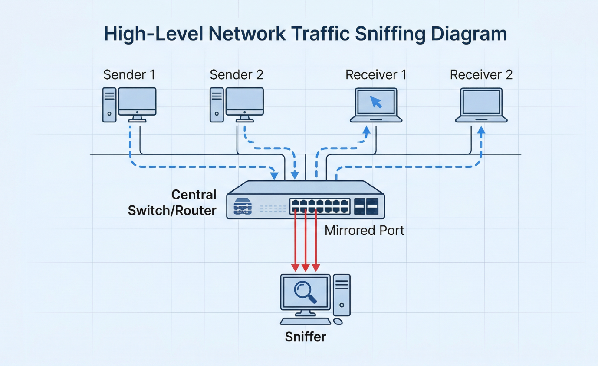
Diagram 2
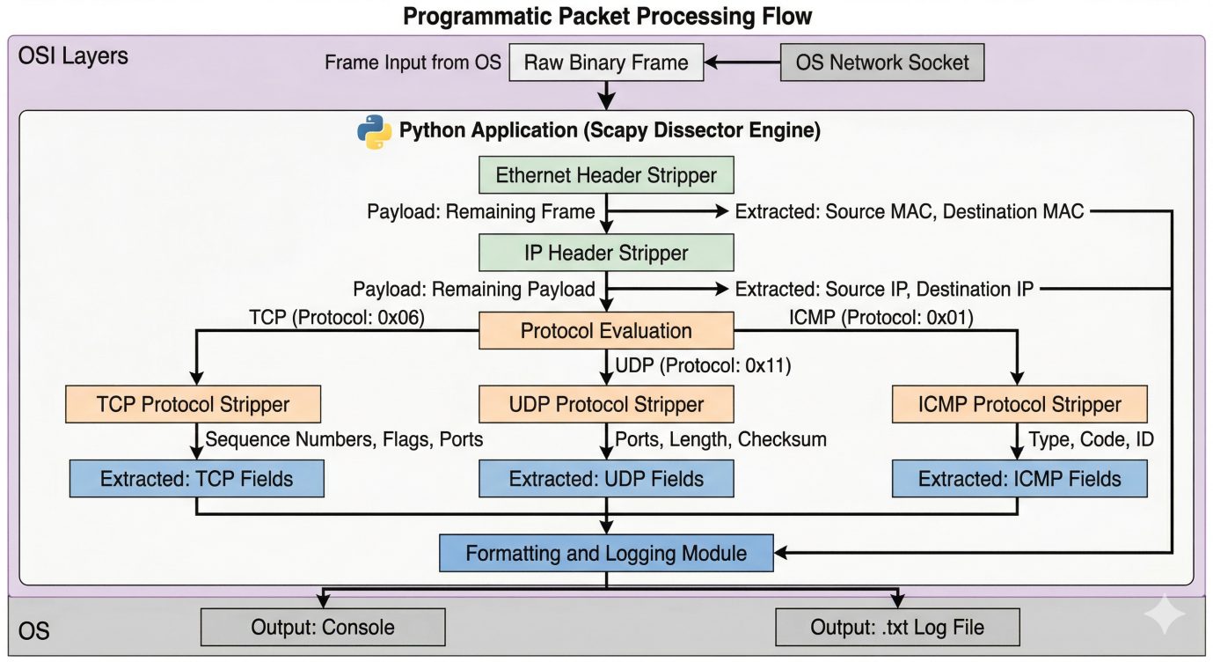
Component Explanation:

- Network Socket/Interface: The physical or virtual boundary (e.g., eth0) that receives the electrical signals and translates them into raw binary frames for the operating system.
- Scapy Engine (The Core): The Python library that acts as the de-encapsulation module. It understands the structural byte-offsets of standard network protocols, allowing it to parse raw hex data into callable Python objects (e.g., pkt[TCP].dport).
- Classification Logic Module: The custom if/else Python statements that filter out noise. This module makes the critical decisions regarding the protocol type and the directional flow of the packet based on local IP comparisons.
- Output Presentation Layer: The terminal standard output (stdout) and flask UI for outputs display on a web page and file I/O operations that write the formatted alert strings to the screen and disk, respectively, providing the user interface for the administrator.

- TOOLS & TECHNOLOGIES

The implementation of this real-time packet sniffer relies on a specific stack of programming languages, libraries, and validation tools.
It is provided as a table below:
Table 2: Feature and Function of Project Technologies

Technology | Description | Key Features | Specific Role in Project Implementation
Python 3 | High-level, interpreted programming language. | Rapid prototyping, extensive standard library, socket support. | Serves as the foundational execution environment and the glue binding all logic and libraries together.
Scapy | Powerful Python-based network manipulation tool. | Packet forging, deep dissection, BPF filtering, PCAP reading/writing. | Acts as the core engine. Replaces the need for heavy tools like Wireshark by providing programmable packet interception (sniff()) and layer parsing.
GeoIP (geolite2) | Offline IP geolocation database library. | Fast lookup, timezone mapping, no API calls required. | Used within the script to instantly map the extracted external Source/Destination IP addresses to geographical regions.
Nmap | Open-source network scanner and security auditor. | Intense port scanning, OS detection, ping sweeps. | Serves exclusively as the attack simulation tool. Used to fire malicious TCP/ICMP probes at the sniffer to verify detection capabilities.
Linux OS | Open-source operating system. | Native raw socket support, advanced networking stack. | Provides the necessary administrative (root) access to place the NIC into promiscuous mode for unfiltered capture.

- IMPLEMENTATION
The implementation of the sniffer requires precise Python scripting to handle socket connections, time tracking, and deep packet inspection. The project is divided into module importation, logging logic, advanced protocol classification, and the main execution loop.
10.1 Setup and Module Importation The script, named basic_packet_sniffer.py, begins by defining the execution environment and importing the necessary libraries.
#!/usr/bin/python
import sys
from scapy.all import *
import socket
import datetime
import os
from geoip import geolite2
import time
Explanation: The scapy.all module imports the entirety of the Scapy framework, granting access to the sniff(), TCP, UDP, ICMP, and IP objects. The socket module is imported to interact with the host OS to retrieve the local machine's IP address. datetime and time are utilized to generate exact timestamps for when a packet is intercepted, which is critical for forensic correlation. The geoip module provides the geographic lookup capabilities.
10.2 Basic TCP Packet Logging Function The first core component is a basic handler function designed to quickly extract standard TCP connections and write them to a log file.

# Function to handle each packet
def handle_packet(packet, log):
# Check if the packet contains TCP layer
if packet.haslayer(TCP):
# Extract source and destination IP addresses
src_ip = packet[IP].src
dst_ip = packet[IP].dst
# Extract source and destination ports
src_port = packet[TCP].sport
dst_port = packet[TCP].dport
# Write packet information to log file
log.write(f"TCP Connection: {src_ip}:{src_port} -> {dst_ip}:{dst_port}\n")
Explanation: The handle_packet function accepts two arguments: the intercepted packet object and the open log file object. It uses the haslayer(TCP) boolean check to filter out non-TCP traffic (like ARP or UDP). It then accesses the network layer variables via packet[IP] to pull the routing addresses, and accesses the transport layer variables via packet[TCP] to identify the application endpoints (ports). Using Python f-strings, it formats this data into a clear directional string (e.g., 192.168.1.5:443 -> 10.0.0.2:55432) and writes it permanently to the disk.
10.3 Advanced Protocol Classification and Alerting Function To provide deep, real-time visualization and directionality (Incoming vs. Outgoing), a more complex function is implemented. This function calculates packet payload sizes, extracts MAC addresses, and resolves Geo-locations.
def network_monitoring_for_visualization(pkt):
# Importing time to get exact time when packet sniffed
time = datetime.datetime.now()

# Classifying packets into TCP
if pkt.haslayer(TCP):
# Classifying packets into TCP Incoming packets
if socket.gethostbyname(socket.gethostname()) == pkt[IP].dst:
print(str("[")+str(time)+str("]") + " TCP-IN:{} Bytes ".format(len(pkt[TCP])) +
"SRC-MAC:" + str(pkt.src) + " DST-MAC:" + str(pkt.dst) +
" SRC-PORT:" + str(pkt.sport) + " DST-PORT:" + str(pkt.dport) +
" SRC-IP:" + str(pkt[IP].src) + " DST-IP:" + str(pkt[IP].dst) +
" Location:" + str(geolite2.lookup(pkt[IP].src).timezone))
Explanation:
- Time Stamp: The exact microsecond the packet hits the function is recorded via datetime.now().
- Directional Logic: The script uses socket.gethostbyname(socket.gethostname()) to dynamically find the IP address of the machine running the script. It compares this local IP to the pkt[IP].dst (Destination IP). If they match, it means the packet is traveling from the network to the host machine, hence it is classified as TCP-IN.
- Data Extraction: The payload size is calculated using len(pkt[TCP]). The MAC addresses are pulled directly from the Ethernet frame using pkt.src and pkt.dst.
- Geo-Location: geolite2.lookup(pkt[IP].src).timezone takes the external source IP of the attacker/sender and queries the offline database to return the geographical timezone (e.g., "America/Los_Angeles").
This precise logic block is replicated iteratively within the function for Outgoing TCP packets (checking if local_ip == pkt[IP].src:), and repeated entirely for pkt.haslayer(UDP) and pkt.haslayer(ICMP) to ensure all major transport protocols are captured, categorized, and printed to the console.
10.4 The Main Execution Block and Packet Sniffing Process The script concludes with the execution wrapper that initializes the log files and starts the Scapy sniffing engine.
def main(interface):
# Create log file name based on interface
logfile_name = f"sniffer_{interface}_log.txt"
# Open log file for writing
with open(logfile_name, 'w') as logfile:
try:
print(f"Starting Packet Sniffer on {interface}...")
print("Press CTRL+C to stop\n")

# Start packet sniffing on specified interface
sniff(iface=interface, prn=lambda pkt: (handle_packet(pkt, logfile), network_monitoring_for_visualization(pkt)), store=0)
except KeyboardInterrupt:
print("\nSniffer Stopped.")
sys.exit(0)

if __name__ == "__main__":
if len(sys.argv) < 2:
print("Usage: python sniffer.py <interface>")
sys.exit(1)
main(sys.argv[1])
Explanation: The main() function accepts the network interface (e.g., eth0) as a command-line argument (sys.argv). It dynamically creates a log file named after the interface. The core engine, sniff(), is called with three critical parameters:
- iface=interface: Binds the sniffer specifically to the provided NIC.
- store=0: A vital instruction that tells Scapy not to store intercepted packets in the computer's RAM. Without this, analyzing a high-speed network would quickly exhaust system memory and crash the machine.
- prn=lambda pkt: ...: The prn parameter dictates what happens to the packet. Here, a Python lambda (anonymous function) is used to pass the single intercepted pkt object to both the file-logging function (handle_packet) and the console-printing function (network_monitoring_for_visualization) simultaneously.
10.5 Technical Explanation of Extracted Packet Headers To understand the implementation, one must understand the anatomy of the packets Scapy is dissecting.
- Ethernet Frame (Data Link Layer): Contains the Source and Destination MAC addresses. These 48-bit hardware addresses define the physical devices communicating on the local subnet.
- IP Datagram (Network Layer): Contains the Source and Destination IP addresses (32-bit for IPv4). These addresses define the logical, global routing endpoints.
- TCP/UDP Segment (Transport Layer): Contains the Source and Destination Ports (16-bit). Ports act as the specific "doors" to applications on the host (e.g., Port 80 for HTTP, Port 443 for HTTPS, Port 53 for DNS). TCP provides reliable, sequenced delivery, whereas UDP provides fast, connectionless delivery.

Table 3: Field Extraction Mapping in the Python Script

Scapy Variable | Protocol Layer | Technical Meaning | Output Representation
pkt.src | Ethernet (Layer 2) | Physical hardware address of the sender. | SRC-MAC: 80:c5:f2...
pkt[IP].dst | IP (Layer 3) | Logical routing address of the intended receiver. | DST-IP: 192.168.10.109
pkt[TCP].sport | TCP (Layer 4) | The port number opened by the sending application. | SRC-PORT: 55172
len(pkt[ICMP]) | ICMP (Layer 3/4) | The total byte size of the ping payload. | ICMP-IN: 64 Bytes

- RESULTS & OUTPUT

The deployment and execution of the custom Python/Scapy packet sniffer yielded highly successful and deeply granular network monitoring capabilities. The system successfully translated unreadable binary network flows into structured, actionable security intelligence in real-time.
Execution and Attack Simulation The script was executed via the command terminal with root privileges: sudo python3 basic_packet_sniffer.py eth0. Immediately, the sniffer began intercepting background network noise (such as DNS requests via UDP). To rigorously test the system's intrusion detection capabilities, a simulated attack was launched from an adjacent terminal using Nmap: nmap -T4 -A -v 192.168.10.109.
Types of Attacks Detected The Nmap command initiates an intense, aggressive scan. The Python sniffer successfully detected:
- Host Discovery (Ping Sweeps): The system captured an abnormal influx of ICMP-IN echo requests attempting to verify if the host was alive.
- Stealth TCP SYN Scans: The system captured a massive, rapid sequence of TCP-IN packets originating from a single source IP, systematically iterating across hundreds of varying destination ports (e.g., port 21, 22, 80, 443) to identify open services.

Sample Alert Outputs and Analysis As the attack occurred, the sniffer printed instantaneous, formatted alerts directly to the console.

Sample TCP Probe Output:
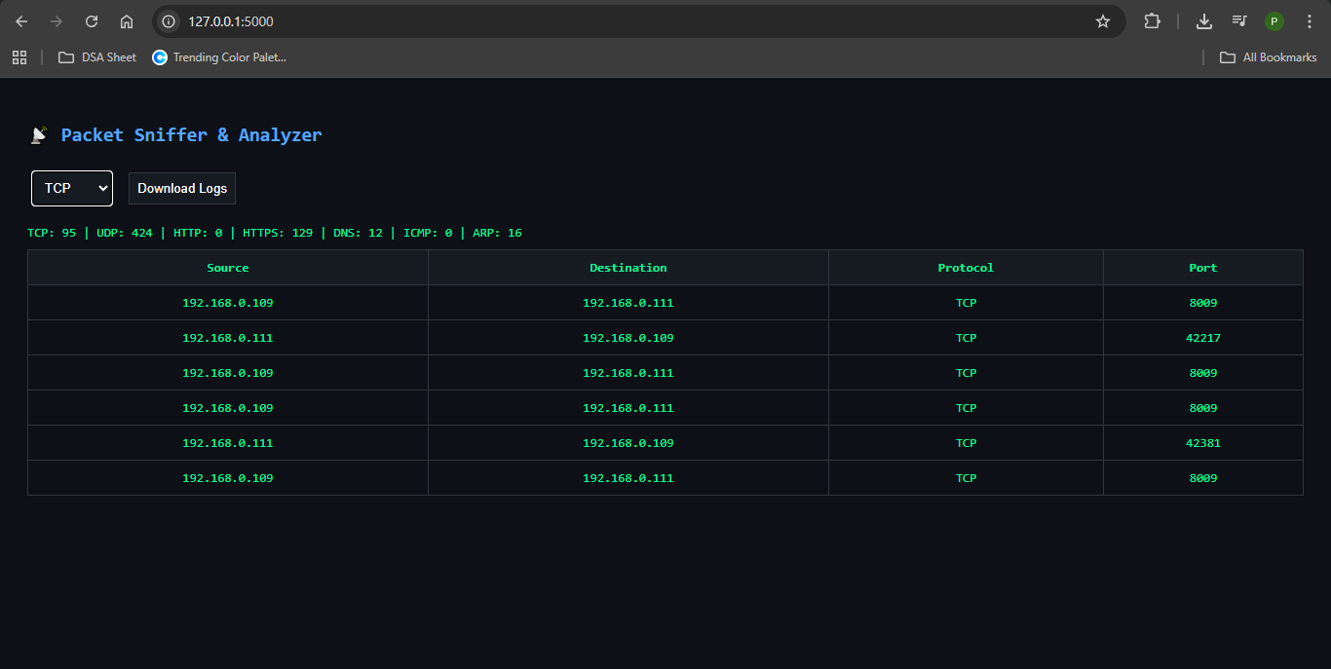
Insights Obtained from the Output:
- Direction & Size: TCP-IN:32 Bytes confirms the packet was entering the system from the outside. The small 32-byte size is indicative of an empty TCP SYN packet used for scanning, rather than a data-heavy application packet.
- Addressing: The SRC-IP and DST-PORT reveal exactly who is attacking and which specific application port they are probing.
Sample Output 2:
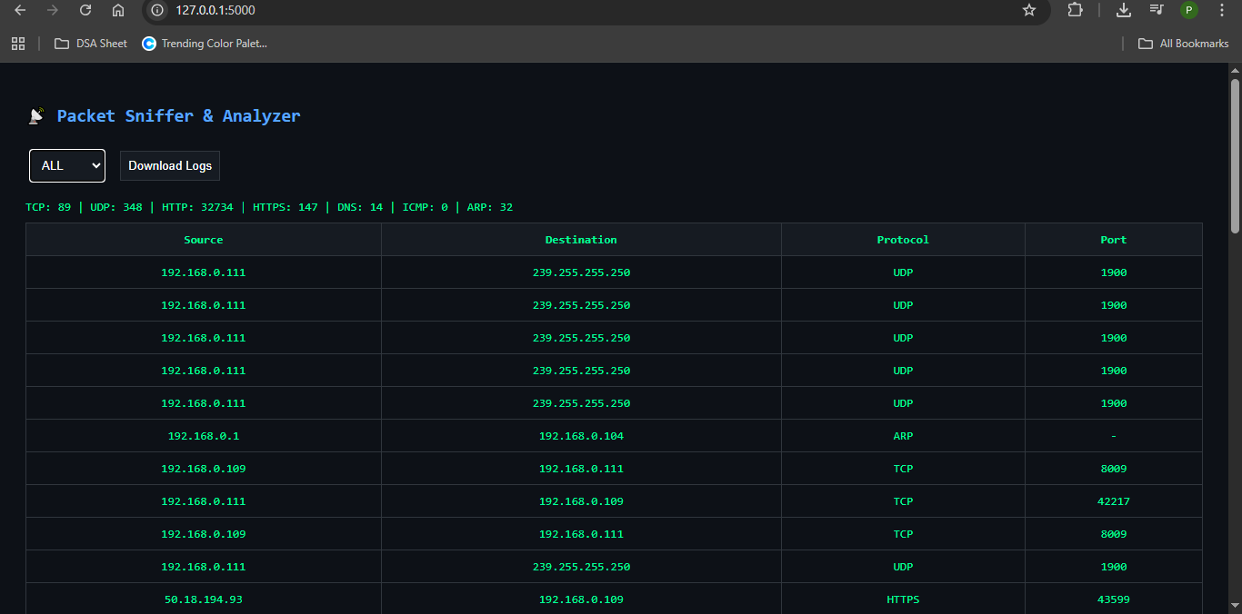

Table 4: Simulated Protocol Scans vs. Sniffer Detection Output
Simulated Traffic Type | Protocol Identified by Script | Detection Indicator in Console/Log | Actionable Insight for Admin
Nmap OS Fingerprinting | TCP-IN & UDP-IN | Rapid alternation between TCP and UDP ports from a single SRC-IP. | The attacker is attempting to identify the host operating system.
Nmap Ping Sweep | ICMP-IN | High volume of 64-Byte packets with matching SRC-IP. | The attacker is mapping the network to find live hosts.
Background Web Browsing | TCP-OUT & TCP-IN | Standard traffic flowing to external DST-PORT: 443 (HTTPS). | Benign network usage; normal operation.

Log Analysis:
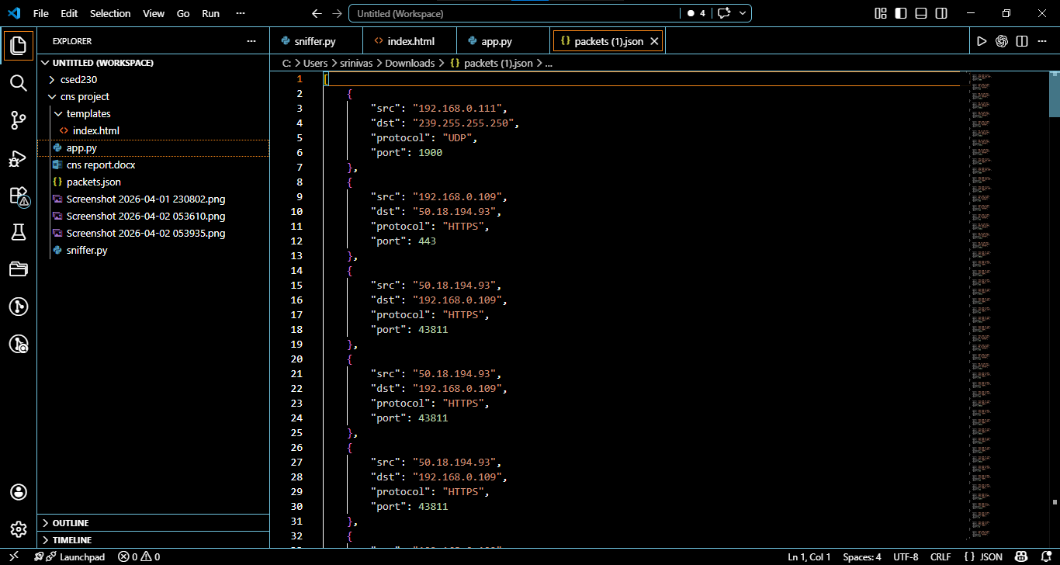
Simultaneously, the foundational TCP data was successfully written to sniffer_eth0_log.txt/ package.json Opening this file using the cat command revealed a persistent, historical ledger of all TCP connections (TCP Connection: 192.168.1.5:443 -> 10.0.0.2:55432). This immutable log acts as a digital flight recorder, allowing incident response teams to forensically trace the exact timeline and methodology of an attacker long after the active scanning has ceased.

- APPLICATIONS

The practical, real-world applications of this custom Python/Scapy-based packet sniffer are extensive and highly relevant across multiple domains of modern IT infrastructure, cybersecurity, and network engineering. The system provides both operational and analytical value by enabling real-time visibility into network traffic.

Proactive Enterprise Security and Threat Hunting
The packet sniffer can be deployed within enterprise networks to enable continuous, passive monitoring of network activity. When integrated with techniques such as port mirroring on managed switches, the system can observe traffic across entire subnets without interfering with communication.
Security teams can use this capability to detect suspicious behaviors such as:
- Unauthorized data exfiltration attempts
- Malware communicating with external command-and-control servers
- Use of non-standard or suspicious ports for covert communication
- Presence of insecure protocols transmitting sensitive data in plaintext
By identifying such anomalies early, organizations can proactively respond to threats before they escalate into full-scale security incidents.

Rapid Network Troubleshooting and Diagnostics
One of the most immediate applications of the system is in network troubleshooting. Administrators can use the real-time packet capture output to diagnose connectivity issues at a granular level.
For example:
- If a server is unreachable, the system can confirm whether TCP SYN packets are reaching the destination
- It can help identify whether packets are being dropped due to firewall rules, routing errors, or network congestion
- It allows verification of correct communication between client and server systems
This reduces debugging time significantly and provides precise insights into where communication is failing within the network.

Bandwidth Monitoring and Protocol Optimization
The system enables analysis of traffic distribution across different protocols, which is essential for optimizing network performance. By monitoring protocol usage, network engineers can:
- Identify bandwidth-heavy applications consuming excessive resources
- Detect unauthorized streaming or file-sharing activities
- Optimize Quality of Service (QoS) configurations
- Balance network load and reduce congestion
For instance, a sudden spike in UDP traffic may indicate unauthorized video streaming or gaming activity, prompting corrective action.

Cybersecurity Education and Practical Learning
The packet sniffer serves as an effective educational tool for students and professionals learning networking and cybersecurity concepts. By exposing real-time packet data, it provides hands-on understanding of:
- OSI model layer interactions
- Packet structure and encapsulation
- Protocol behavior (TCP, UDP, ICMP, etc.)
- Network vulnerabilities and the importance of encryption
It helps learners move beyond theoretical knowledge and directly observe how data flows across a network, reinforcing key concepts through practical experimentation.

Intrusion Detection System (IDS) Foundation
The system can act as a foundational component for building more advanced security solutions such as Intrusion Detection Systems (IDS). By capturing and classifying packets, it provides the core functionality required for:
- Detecting abnormal traffic patterns
- Identifying scanning activities (e.g., port scans, ping sweeps)
- Monitoring repeated connection attempts or unusual protocol usage
With further enhancements such as signature matching or anomaly detection, the system can evolve into a full-fledged IDS.

Digital Forensics and Incident Analysis
The logging capability of the system allows captured packet data to be stored for later analysis. This is particularly useful in digital forensics, where investigators need to reconstruct events after a security incident.
Applications include:
- Tracking suspicious communication patterns
- Analyzing historical traffic logs
- Identifying sources of malicious activity
- Supporting post-incident investigations and reporting

Network Policy Enforcement and Compliance Monitoring
Organizations can use the system to ensure compliance with internal security policies and regulatory standards. By monitoring network traffic, administrators can:
- Detect use of unauthorized applications or protocols
- Ensure sensitive data is not transmitted over insecure channels
- Enforce restrictions on specific ports or services
This helps maintain a secure and compliant network environment.

Research and Development in Networking
The system can also be used in research environments to study network behavior under different conditions. Researchers and developers can analyze:
- Traffic patterns under varying loads
- Protocol efficiency and performance
- Effects of network configuration changes
This makes it useful for experimentation and development of new networking techniques.
.

- FUTURE ENHANCEMENTS

While the current Python implementation is a functional and efficient packet sniffing and analysis system, several advanced enhancements can significantly extend its capabilities, transforming it into a comprehensive network security and monitoring suite.

Heuristic Intrusion Detection System (IDS) Integration
The current system primarily performs passive monitoring and logging. A major enhancement would involve integrating heuristic-based intrusion detection mechanisms. By defining threshold-based rules (for example, detecting more than a specified number of TCP SYN packets per second), the system can automatically identify suspicious patterns such as port scans, brute-force attempts, or denial-of-service attacks. This would enable real-time alert generation and move the system toward an intelligent anomaly detection engine.

Active Intrusion Prevention System (IPS) Conversion
Beyond detection, the system can be extended into an Intrusion Prevention System (IPS). By integrating with firewall utilities such as iptables or ufw, the script can dynamically generate and apply rules to block malicious IP addresses or ports. For instance, if repeated suspicious activity is detected from a specific source, the system can automatically blacklist that IP, providing real-time defense rather than passive observation.

PCAP File Generation and Forensic Analysis
Currently, the system logs packet data in text or JSON format. A significant enhancement would be the integration of Scapy’s wrpcap() functionality to store captured packets in standard .pcap format. This would allow the data to be analyzed using advanced forensic tools such as Wireshark or NetworkMiner, enabling deep offline analysis, replay of network traffic, and detailed investigation of security incidents.

Payload Inspection and Deep Packet Analysis
The existing system focuses primarily on header-level analysis. Future improvements can include deep packet inspection (DPI), where the payload content of packets is analyzed for malicious signatures or suspicious patterns. This would allow detection of hidden threats such as embedded malware, unauthorized data transfer, or protocol misuse.

Machine Learning-Based Anomaly Detection
A major advancement would involve integrating machine learning models to analyze traffic patterns and detect anomalies. By training models on normal network behavior, the system can automatically identify deviations such as unusual traffic spikes, unknown protocols, or abnormal communication patterns. This would significantly improve detection accuracy compared to static rule-based systems.

Real-Time Alerting and Notification System
The system can be enhanced with automated alert mechanisms such as email notifications, SMS alerts, or integration with messaging platforms like Telegram or Slack. When suspicious activity is detected, the system can immediately notify administrators, enabling faster response and reducing potential damage.

Advanced Web Dashboard and Data Visualization
The current Flask-based interface can be upgraded into a more interactive dashboard. Enhancements may include graphical representations such as protocol distribution charts, traffic timelines, and real-time network graphs. Integration with visualization libraries can provide better insights into network behavior and improve usability.

Multi-Interface and Remote Monitoring Support
The system can be extended to monitor multiple network interfaces simultaneously, including both wired and wireless connections. Additionally, remote monitoring capabilities can be introduced, allowing administrators to view packet data from different machines or network segments through a centralized dashboard.

Encrypted Traffic Analysis and TLS Metadata Inspection
Although decryption of encrypted traffic is not always feasible, the system can be enhanced to analyze TLS metadata such as certificate details, handshake patterns, and server information. This allows detection of suspicious encrypted connections without violating encryption protocols.

Integration with SIEM Systems
The system can be integrated with enterprise-level Security Information and Event Management (SIEM) platforms. By exporting logs in structured formats such as JSON, the captured data can be aggregated with other security logs, enabling centralized monitoring, correlation, and advanced threat detection.

Automated Reporting and Log Analysis
Future versions can include automated report generation that summarizes network activity over time. This may include daily or weekly reports highlighting protocol usage, detected anomalies, and traffic trends, which can assist in auditing and compliance requirements.

- CONCLUSION

This project successfully details the design, theoretical foundation, and practical implementation of a Real-Time Network Packet Sniffer. By leveraging the Python programming language and the Scapy manipulation framework, the project circumvented the reliance on heavy, resource-intensive graphical tools, resulting in a lightweight, highly responsive, and deeply customizable cybersecurity utility.

The implementation demonstrated a robust programmatic ability to intercept live network datagrams across a shared Ethernet environment by utilizing promiscuous socket binding. The script systematically stripped away Data Link and Network layer encapsulation to extract critical routing metadata, including MAC addresses, IP addresses, and application ports. Through meticulous programmatic logic, the system effectively categorized live traffic into distinct TCP, UDP, and ICMP streams, dynamically classifying the directional flow of data relative to the host machine.

During rigorous simulation testing using industry-standard tools like Nmap, the custom sniffer successfully intercepted, dissected, and logged aggressive network probing, stealth port scans, and host discovery sweeps. It generated instantaneous, formatted, timestamped alerts enhanced with Geo-IP localization, providing actionable security intelligence directly to the terminal console. Ultimately, this project underscores the inherent vulnerabilities of data transmission over IP networks. It proves that possessing the scripting skills to build custom packet inspection tools is an invaluable asset for security professionals, reinforcing the reality that automated, deep-packet visibility is the foundational cornerstone of modern proactive cyber defense.

- REFERENCES

- R. Poudel, "Writing a Quick Packet Sniffer with Python & Scapy," GitHub Repository Data.
- Y. Lote, "Developing a Basic Network Packet Sniffer," Medium, Feb 6, 2024.
- GeeksforGeeks, "Packet sniffing using Scapy," Jul 5, 2021.
- GeeksforGeeks, "What is Packet Sniffing?," Mar 23, 2023.
- R. Tuli, "Packet Sniffing and Sniffing Detection," International Journal of Innovations in Engineering and Technology (IJIET), vol. 16, no. 1, pp. 22–32, April 2020.
- W. Richard Stevens, "TCP/IP Illustrated, Volume 1: The Protocols," Addison-Wesley, 1994.
- Andrew S. Tanenbaum and David J. Wetherall, "Computer Networks," 5th Edition, Pearson, 2011.
- J. F. Kurose and K. W. Ross, "Computer Networking: A Top-Down Approach," 7th Edition, Pearson, 2017.
- Scapy Documentation, "Scapy: Packet Manipulation for Python," Available: https://scapy.net
- Wireshark Foundation, "Wireshark User Guide," Available: https://www.wireshark.org/docs/
- RFC 791, "Internet Protocol (IP)," Internet Engineering Task Force (IETF), 1981.

